- Product Overview: -

The WIN-SN-TNH-PM-M-(OD) is an industrial-grade outdoor environmental monitoring sensor designed for accurate measurement of Temperature, Humidity, and Particulate Matter (PM1.0, PM2.5, and PM10). The device is equipped with an RS485 communication interface and supports the Modbus RTU protocol, enabling seamless integration with PLCs, SCADA systems, IoT gateways, data loggers, and Building Management Systems (BMS).
The sensor is designed for reliable operation in demanding outdoor environments and provides real-time monitoring of environmental conditions. User-configurable communication parameters such as Modbus Slave ID, Baud Rate, Parity, and Stop Bits can be easily modified through software settings, allowing flexible deployment across various industrial and smart monitoring applications.
The WIN-SN-TNH-PM-M-(OD) is suitable for applications including air quality monitoring, industrial automation, smart cities, weather monitoring stations, environmental compliance systems, warehouses, commercial buildings, and other outdoor monitoring installations.

- Key Features
- Measures Temperature, Relative Humidity, PM1.0, PM2.5, and PM10 concentrations.
- Industrial-grade sensor designed for outdoor environmental monitoring applications.
- RS485 communication interface with Modbus RTU protocol support.
- Real-time measurement and transmission of environmental data.
- User-configurable Modbus communication parameters.
  - Modbus Slave ID
  - Baud Rate
  - Parity Setting
  - Stop Bit Configuration
- High accuracy and stable performance for continuous monitoring.
- Easy integration with PLCs, SCADA systems, IoT gateways, and data loggers.
- Wide operating temperature range suitable for harsh environments.
- Low maintenance and long operational life.
- Robust enclosure designed for outdoor installations.
- Fast response time for environmental parameter monitoring.
- Supports multi-drop RS485 network architecture.
- Reliable communication over long cable distances.


- Suitable for smart city, industrial automation, air quality monitoring, weather stations, warehouses, and building management applications.
Certifications:

Sensor Specification:-

Measuring Parameter | Measuring Range | Accuracy
PM 1. 0 | 0 ~ 1000 ug/m3 | 5 μg/m3 10 % m.v.
PM 2.5 | 0 ~ 1000 ug/m3 | 5 μg/m3 10 % m.v.
PM 10 | 0 ~ 1000 ug/m3 | 25 μg/m3 25 % m.v.
Temperature | -40 °C to +120 °C | ±0.3 °C
Humidity | 0 ~ 100 % RH | ±2 % RH

- Technical Specifications
- Operating Voltage: 12-24v DC
- Interface: Modbus RS485
- Function Code: 0x03
- Product dimension (D X H) : 140 X 200 mm

- Communication and Configuration Settings:-

The WIN-SN-TNH-PM-M-(OD) communicates using the RS485 interface with the Modbus RTU protocol. The device is factory-configured with a Baud Rate of 9600 bps, Slave ID 1, Parity setting 3, and 1 Stop Bit, allowing quick deployment in standard Modbus networks.
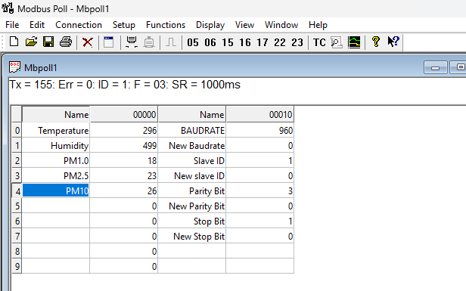

To support a wide range of industrial applications, communication parameters can be modified through software settings. Users can configure the Baud Rate up to 115200 bps, assign a Modbus Slave ID from 1 to 247, and adjust the Parity and Stop Bit settings according to system requirements. These configurable parameters provide flexibility for integration with PLCs, SCADA systems, IoT gateways, HMIs, and other Modbus-compatible devices.
Example screenshots illustrating the software configuration procedure are provided below for reference.

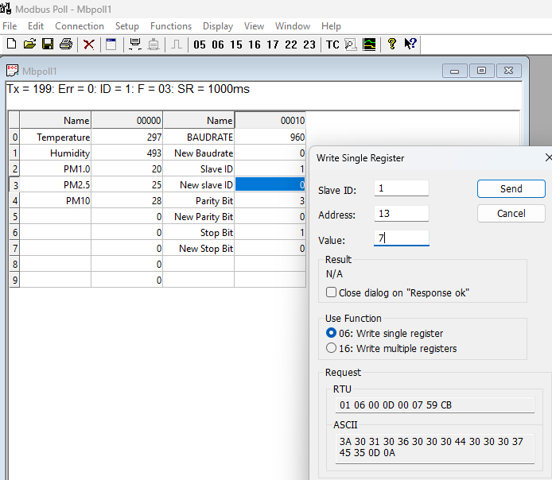

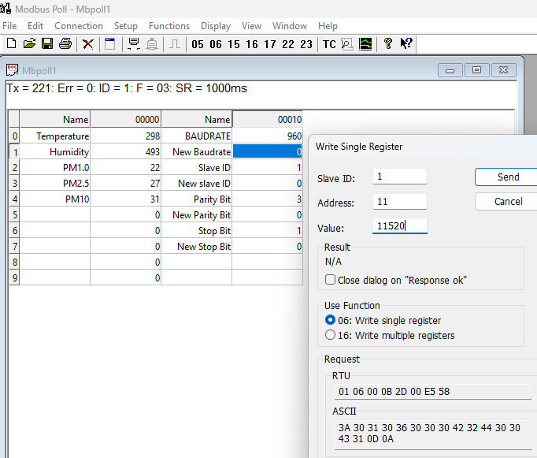

Factory Reset:-
The device includes a factory reset feature that restores all communication parameters to their default settings. To perform a factory reset, place the configuration jumper in the Factory Reset position and press and hold the Reset button for approximately 5 seconds. The device will automatically restart and restore the factory default communication settings:
- Baud Rate: 9600 bps
- Slave ID: 1
- Parity: 3
- Stop Bit: 1
This feature allows users to quickly recover communication with the device if the configured settings are unknown or incorrectly configured.

- Modbus Register Values :-
ID | Function Description | Register Description | Modbus Function  Code | Protocol | Data Type
1 | Temperature | 40000 | 0x03 | RS485 | 16-bit int
2 | Humidity | 40001 | 0x03 | RS485 | 16-bit int
3 | PM1 | 40002 | 0x03 | RS485 | 16-bit int
4 | PM2.5 | 40003 | 0xo3 | RS485 | 16-bit int
5 | PM10 | 40004 | 0x03 | RS485 | 16-bit int

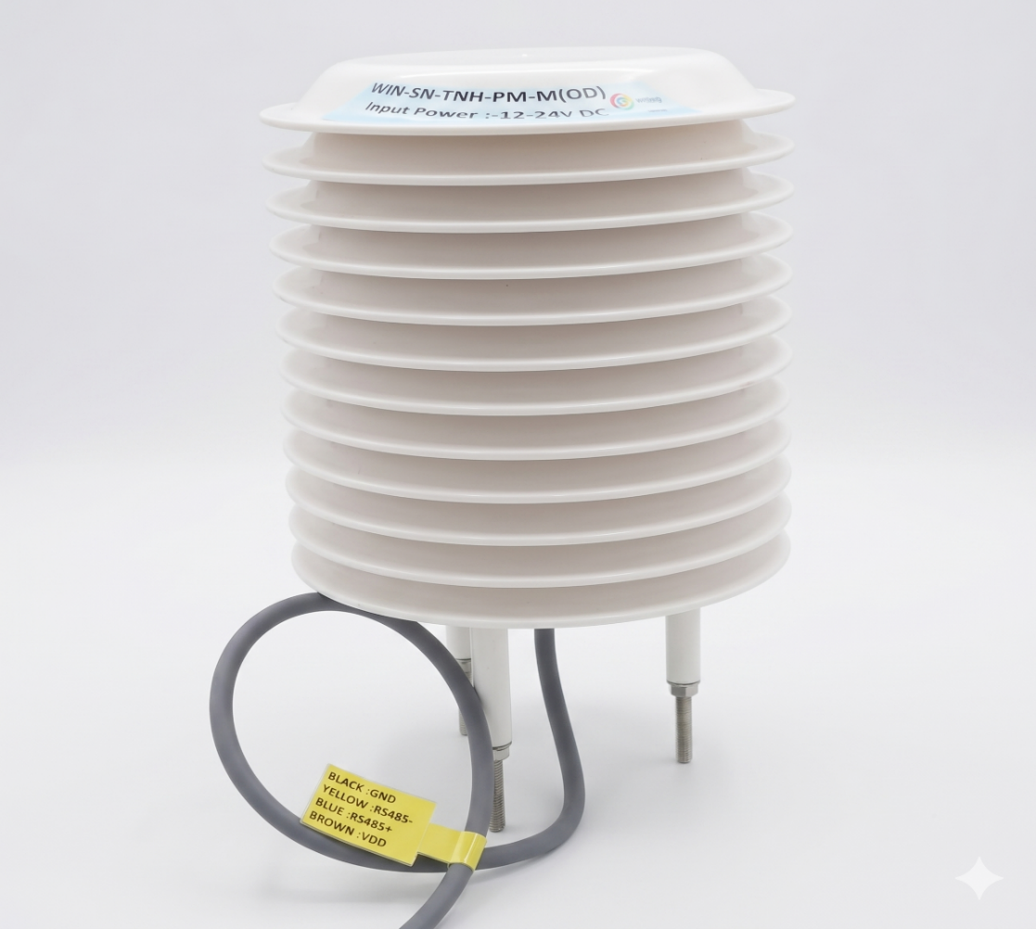

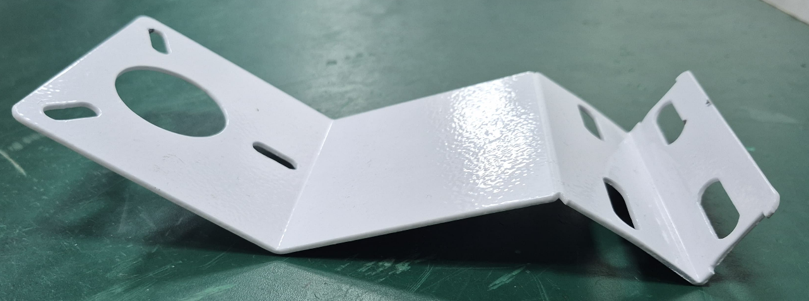
Note – The base Plate is provided for easy installation on Pole etc.

Contact Information
Augmatic Technologies Pvt. Ltd.,
Plot no 6, Shah Industrial Estate II,
Kotambi,
Vadodara – 391510.
Email – Sales@wittelb.com
Support E.: support@wittelb.raiseaticket.com / M.: 9403892805

